EHS Coaching Information 2023/234

Training Certificates Required:
- Please complete the following courses on the SHSAA link below and provide the certificates to tracy.huckell@gssd.ca.
  - Respect in Sport
  - Concussion Protocol

Criminal Record/Vulnerable Sector Check (CRVC)
- All volunteers/coaches working with students must submit a recent CRVC (within 6 months) to the main office as per GSSD policy. These can be completed at no cost at the Esterhazy RCMP office.

GSSD Code of Conduct
- All volunteers/coaches must complete this online at this link -

School Alarm System & Doors:
- Weekdays - You can unlock the set of doors closest to the gym you are using and remember to relock them after everyone has left. No need to touch the alarm system provided you are out before midnight.
- Weekends – the alarm will be armed, so you need to enter through the main entrance, type your alarm code into the system if it is armed (red), and put your name on the whiteboard to inform others you are in the building. If it is not armed (shows green check) just put your name on the board and erase it when you leave. If you are the last person left in the building (no names on the whiteboard), arm the system with your code and leave through the main entrance/exit (alarm will turn red and beep when you arm it).
- If you accidentally set off the alarm, please text/call Rick Heise (306-740-7475) or Tracy Huckell (306-740-7960) as we will get a call from Securetek.

Gym Use:
- No food or drink should be in the gyms other than water. Please ensure your players clean up after practices and games – check bleachers and floor for garbage and gym washrooms – previous issues with messes and vandalism.
- Sr. Gym - Ensure the emergency door and exit door by the boy’s changerooms are both closed and latched (students sometimes open these doors when they are hot).
- Remind students to remove wet/muddy footwear at the entrance so they don’t dirty floors when entering for practices.
- Please ensure you are on time for scheduled practices so that the school doors are open for students (especially on cold days) and so students are supervised when they are inside the school/gym.
- Gym Lights:
  - Weekends: Turn off all lights off if you are the last in the gym (and hallway lights too which are located just outside the sr. and jr. gym doors).
  - Weekdays: The caretaker will turn off the lights after the last practice of the night.
- Volleyball/basketball scoresheets are located in the PE teacher’s office filing cabinet???
- Return all items used for practices/games to the location you found them in.
- After home games, please have your team pick up any bottles or garbage that are on the bleachers (the top level is the worst for accumulating garbage) before closing up the bleachers. This is difficult for one caretaker to do alone but easy for a team to do together.

Booking Gyms
- Gym time can be booked with Jodi Denbrok in the main office at GSSD (306) 745-6618 or jodi.denbrok@gssd.ca.
- Games take precedence over practices.
- Practices are in 2 hour blocks. Please follow the prescribed times to be fair to all teams.

Booking Officials for Games
- The coaches usually do this on their own. For basketball, Shayna Zubko will complete this the paperwork to pay officials as well.

Reporting Injuries
- If a student is injured, email tracy.huckell@gssd.ca and audrey.marchand@gssd.ca and inform their parents. Audrey will complete the online School Accident Report through Marsh Canada with the info from your email, with the exception of football who completes their own.

Reimbursement of Expenses
- Coaches can be reimbursed for mileage and meals using GSSD Form 517-1. This can be submitted to Audrey Marchand.

Uniforms and Team Fees
- Collect team fees from students before jerseys are handed out to students – Audrey/Jodi can help with collecting fees from students and will help you find the uniforms. Students are responsible for washing their own uniforms.
- If you have difficulty collecting from students who can pay, speak to Tracy/Rick as they need to pay the fees to be on the team (unless we decide they are waived due to financial difficulties).

Travelling with Students
- Coaches can take 15 passenger van training through GSSD to be able to transport students using our 15 passenger vans. Please complete the log located on the dash before driving and inform main office/admin. of any issues noted with the van.
- Fuel tank on the van is located on driver’s side behind driver door. Fuel up at Mohawk when you return to Esterhazy and sign Mohawk’s logbook to charge the fuel. Have students clean up inside of van as you fuel so that no garbage is left inside.
- If arranging parents to transport students, they must complete a GSSD driver’s abstract form and submit it to Audrey in the main office prior to the game. Refer to attached forms.
- Please remind students that GSSD/EHS policy is that they are not allowed to transport themselves or others to games.

Please ensure the travel forms below are completed PRIOR to parents transporting other peoples’ children.
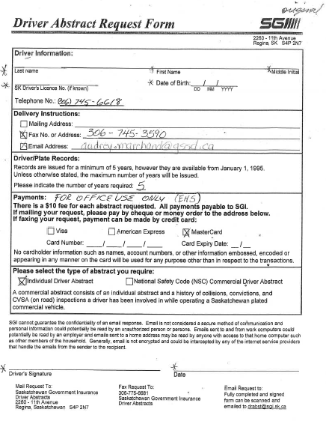

Parents driving students must complete this and submit to office:

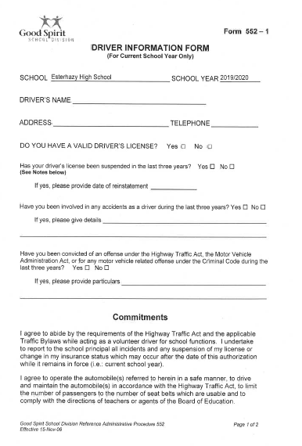

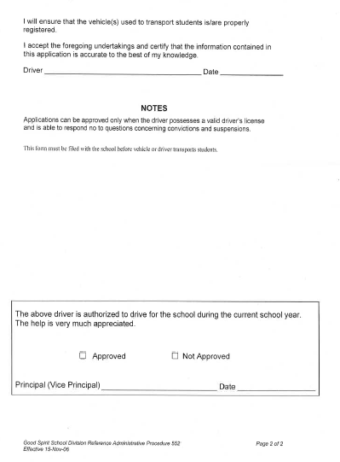

Parents are to complete this to allow their child to travel with another parent:

